The Effect of Policies on Smoking Rates: The Extended Smoking Base Case
David T. Levy, PhD
January 2014

INTRODUCTION
Simulation models developed by six Cancer Intervention and Surveillance Modelling Network (CISNET) lung groups were recently used to examine the effect of smoking on lung cancer deaths in the US population from 1975 to 2000.¹ For their model’s generation of population-based smoking status, all models used a common set of data, known as the smoking base case data, consisting of smoking prevalence, cessation rates, smoking intensity (cigarettes smoked per day) and age of initiation (duration).² The data was initially developed from the National Health Interview Survey (NHIS) from 1975 to 2000. Individual-level smoking histories were generated by the smoking history generator (SHG) for stochastic cohort analyses and data were also made available in aggregate form by age and gender and via a smoking history generator. Using an age-period-cohort analysis, Holford et al. (2013) have since extended this data through 2009 and project trends in smoking prevalence through 2050. In projecting future trends, Holford et al. assume that recent smoking intensity, initiation and cessation rates will continue into the future. The projection of these rates implicitly assumes that recent tobacco control policies are maintained into the future.
Despite the overwhelming evidence of its harmful effects, about 18% of adults in the US still smoked cigarettes in 201.³ In addition, Levy et al and Warner and Mendez project that, in the absent of major policy changes, smoking prevalence will fall slowly to about 17.5% in 2020. The Healthy People 2020 (HP 2020) goal of reaching a 12% smoking prevalence in adults appears out of reach absent policy change. In this paper, we consider the effect of a stricter set of policies that would meet most of the policy goals set by Healthy People 2020. We develop a set of parameters to reflect those policies and use those parameters to provide preliminary estimates of the effect of HP 2020 policies on male and female smoking prevalence and to determine if the HP 2020 goal is attainable.
METHODS
Structure of Tobacco Control Policy Model
Effects on smoking initiation, cessation, intensity, and quantity
The smoking history generator relies on initiation and cessation rates by age and gender to project smoking prevalence forward. We allow for differential policy effects on initiation and cessation based mostly on evidence related to the relationship between policies and smoking prevalence rates.⁴⁰ Cessation rates are defined in terms of having quit for two years, which reflects a trade-off between higher cessation rates in the first year and the additional relapse that may be expected after the first year.⁹⁻¹¹ Since evidence of how policies affect relapse rates is sparse, we assume no relapse after the second year focusing on the two year cessation rate.
The smoking generator also provides estimates of smoking dose and intensity. The effects of policy on duration will occur through the effects of policy on the distribution of initiation. The effects on quantity smoked depend on the policies implemented, but, at a population level, quantity smoked could increase if those who quit as a result of the policies are lighter smokers. We employ conservative estimates of the effects of policies on quantity smoked.
Variations in Policy Effects by Gender, Age, Cohort and Year
Because previous studies have not consistently found differential effects of policy by gender, the effects are assumed the same for males and females, but incorporate different effects by age.¹²⁻¹⁶ However, because the empirical literature has not distinguished policy effects by birth cohort, we do not incorporate cohort effects. The effects of a policy are also assumed to be independent of the year in which it is implemented.
Time patterns of policy effects
Studies have found that policies have their greatest influence on smoking prevalence or consumption in the first few years after they are implemented.¹²⁻¹⁶ Smokers who are most amenable to quitting are likely to quit when the policy is first implemented. In ensuing years, those who tried to quit and fail may be less likely to try again, and may be more likely to fail if they do. Previous iterations of SimSmoke have generally modelled the most direct effects of tobacco control policies in the first few years following implementation.¹⁷⁻²³
To capture the diminishing effect of policies after the first year of implementation, we assume a geometric decline in the effect on the population quit rate (PQR), i.e., for an annual decay rate of δ%, PQR_{status quo}+ [PQR_{with policy} - PQR_{status quo}] * (1- δ%)^{i-1} in the ith year that the policy has been in place. This structure implies that the effects decline by the same percentage each additional year that the policy is in effect. We assume an initial 10% decay rate in cessation for all policies based on short-term versus long-term differences in prevalence effects found in previous policy studies.¹²⁻¹⁶ However, we also consider upper and lower bounds of 0% and 25% decay rates. This decay is not applied to the effect of policies on initiation rates.
Effects of combined policies
The effect of policies may vary when more than one policy is implemented. However, studies of the effect of combined compared to individually-implemented policies are sparse.²³ The effects may be independent (implying additive effects), synergistic (implying that effects of combined policies are greater than their individual effects), or offsetting effects (implying that the effect of combined policies is less than their individual effects).⁴⁰ In the latter case, we allow for the partial offset of future policies on initiation by assuming that the effect of a second policy is reduced proportionally by the effect of the first policy.
For a policy which reduces initiation rates by x%, the effect on initiation rates is obtained by multiplying those rates by (1 - x%). For three separate policies which reduce initiation rates by x%, y% and z% , we consider two cases: 1) constant proportion reductions: the combined effect on pre-policy initiation rates is (1 - x%) * (1 - y%) * (1 - z%), which bounded between 0 and 1, and 2) the effects are additive, i.e. (1 - x% - y% - z%), which the restriction that (x% +y% +z%)<1.
For a policy which increases cessation rates by x’% (x>0), the policy effect is obtained by multiplying cessation rates by (1 + x’%). For three policies with cessation effect sizes x’%, y’% and z’% (> 0), we consider three cases: 1) the constant proportional increases case: [1 + x’%]*[1 + y’%*(1-x’%)]*[1 +z%*(1-y’%)*(1-z’%)], where x’%> y’% > z’%. This case implies that the additional policy affects those who have not quit as a result of the more potent policy, thus allowing some offsetting effect of additional policies, 2) (1+x’%+y’% +z’%).The effects on cessation are additive implying no synergy or offsetting effects, and 3) the synergistic case: (1 + x’%) * (1 + y’%) * (1 + z’%).
The Effect Sizes of Specific Tobacco Control Policies
We initially model the effects of four tobacco control policies that figure most prominently in US tobacco control: 1) tobacco taxes, 2) smoke-free air laws, 3) mass media/educational campaigns, and 4) quitlines. We also consider other potential policies below.
Dependence on past policies
The effect of a newly implemented policy will generally depend on state and federal policies currently in practice. For example, the effect of a new smoke-free air law is expected to be smaller in a state with laws already in effect (e.g., limits smoking to common areas) than in a state with no restrictions. Similarly, the effect of a tax increase will depend on current tax rates as reflected in the current price, e.g., a $1 price increase has a larger relative effect if the initial price is $2 (i.e., 50% higher) than if it is $4 (i.e., 25% higher).
While the analysis here is conducted at the national level, most tobacco control policies are implemented at a state level, where there is wide variation in policies. To incorporate the policy effects across states, a population-weighted average of state policies in effect is applied.
For each policy, we discuss the relevant inputs to characterize the policy, and then develop policy effect sizes for initiation, cessation and quantity smoked. The effect sizes are primarily based on parameters developed for the SimSmoke model, which are based on extensive reviews of the policy literature, expert panels, and validation of the model in four states²⁴⁻²⁷ and more than 20 countries.²⁸⁻³⁸ In a recent paper, Levy et al model the effects of policies on cessation rates through the quit attempts and through quit success (which are multiplicative). We build on that work, and develop effect sizes for initiation rates and quantity smoked.
Price change through cigarette tax increases
Currently, excise taxes on cigarettes in the U.S. are per unit (i.e., specific taxes per pack) and are levied at both the federal and state level. In November 2010, federal taxes were at $1.01 per pack and state taxes averaged $1.53 per pack, although varying from $0.30 in Virginia to $4.35 in New York State (http://www.tobaccofreekids.org/research/factsheets/pdf/0222.pdf).
For simplicity, we model the effect of a federal tax increase applied to all states relative to a weighted average of prices across states, whereby a single tax rate is applied to the price. Based on past studies, we assume that the new tax is directly passed on to consumers by the amount of the tax, i.e., the new price is the pre-tax price plus the tax. Following standard economic practice, the effect of a tax depends on the price elasticity, measured as the percentage change in smoking rates relative to the percent change in price. By assuming a constant price elasticity over all price ranges, the percent change in price is averaged over the pre-and post tax price, i.e., (P_{post-tax} – P_{pre-tax})/(P_{post-tax} + P_{pre-tax})/2,⁴³ which is multiplied by the cessation and initiation elasticities.
While many studies examine the effect of cigarette price changes on smoking prevalence, few report the impact of price on quit rates, although several studies report their impact on one or more of the components of the quit rate. Although Franz, Tauras and Chaloupka⁴⁴ and Levy et al⁴⁵ found less percentage change in cross sectional studies, Reed et al⁴⁶ found that a tax-induced 60% increase in cigarette prices was followed by a doubling of quit attempts. However, studies are sparse and effects vary considerably. Based on studies of prevalence elasticities, we estimate that a 10% increase in price leads to a 20% increase in cessation rates (10% through quit attempts and 10% through quit success) across all age groups. For example, a federal tax increase of $0.55 with a current price of $5.50 yields a 10% increase in price (i.e., 0.55/(5.50+6.05)/2), which would increase the cessation rate by 20% with an upper bound 25% above and a lower bound 25% below 20%.
Studies find that the price elasticity is higher at lower ages reflecting lower levels of addiction and income.⁴³ Initiation rates are reduced 4% for each 10% increase in price by those ages 10-17, 3% for those ages 18-24 and 1% for ages 25-30.⁴³Accordingly, initiation rates are reduced by 4% for each 10% increase in price by those ages 10-17, by 3% for those ages 18-24 and by 1% for ages 25-34.⁴³ Previous studies have generally found that the price elasticity with respect to quantity sold is close to the prevalence elasticity: -0.4 for those ages 10-17, -0.3 for those ages 18-24, -0.2 for those ages 25-34 and 65 and above, and -0.1 for those ages 35-64.⁴⁰
Smoke-free indoor air laws
Smoke-free air laws (SFALs) are implemented at a state and city level and vary in terms of the stringency in which they are applied to each of the categories: worksites (private and public), restaurants and bars. By the end of 2013, 24 states had SFALs in all workplaces, restaurants, and bars (representing 49% of the population), an additional 10 states had complete bans in restaurants (77% in total) and an additional 5 states in bars (65% in total), and 5 stated had only a worksite ban (65%). Most other states have at least some restrictions on smoking, and many cities have SFALs (www.no-smoke.org/pdf/SummaryUSPopList.pdf).
Based on previous studies,⁴⁸ complete SFALs for workplaces, restaurants and bars reduce smoking prevalence by 9% within 5 years, apportioned at 6% for worksites, 2% for restaurants are 2%, and 1% for bars. Cross-sectional studies comparing workplaces with smoke-free policies to those with no smoke-free policies have generally found a 20%-40% higher likelihood of quit attempts among smokers⁴⁹ and a 10-30% higher likelihood of quit success.⁴⁹⁻⁵¹ Using the midpoint effects of smoke-free policies, we estimate that implementing smoke-free indoor workplace air laws at the workplace increases quit attempts by 30% (midpoint of 20%-40%) and quit success each by 20% (midpoint of 10-30%) among workers who were smokers before the policy was implemented, or an overall increase in the cessation rate of 60% by those of working age. Restaurant bans and bans in pubs increase cessation rates by 20% and 10%, respectively. Since those above age 64 are less likely to work and therefore less affected by worksite laws, we reduced the effects by half for those above age 64.
To maintain the effects of a ban, initiation rates are reduced by 6% for worksite, 2% for restaurants, and 1% for bars. The rates are applied to initiation rates for workplaces at half the rate, reflecting that youth and young adults are less likely to work. Quantity smoked is reduced by 6% for worksite bans, 2% for restaurants and 1% for bars. With 65% of the population already covered by smoke-free workplace and bar laws,⁵² the incremental impact on cessation and initiation rates is 65%. Similarly, the effect for restaurant laws is a 77% reduction.
Tobacco control campaigns
Tobacco control campaigns primarily include most educational programs, such as media campaign and state and local programs. Data is available on overall tobacco control expenditures by state, much of which is for media and other state and local educational campaigns. The Centers for Disease Control and Prevention (CDC) has developed recommended levels of per capita tobacco control expenditures by state. We use these criteria to classify states in terms of high, medium and low level campaign intensity. State spending in 2013 on tobacco control campaigns (most of which is spent on mass media) was at about 15% of the CDC recommended minimum averaged across states,⁵⁸ with no states at the maximum and few states above 50% of the recommended minimum.
Evidence indicates that health communication campaigns as defined by the CDC can achieve substantial reductions in tobacco use. Levy et al⁴⁵ found a 45% higher rate of quit success among smokers making a quit) in states with media-focused tobacco control programs compared to those without campaigns, while Hyland et al⁵⁵ found that the percent of smokers who had quit after 8 years was 44% higher in states with a strong tobacco control programs. Using data in Burns et al,⁵⁰ California had a 15% higher and Massachusetts had a 20% higher annual rate of quit attempts, and California had a 36% higher and Massachusetts had a 22% higher rate of quit success than the average of the comparison states in 1996. Based on these findings and on studies of prevalence,⁵⁶ we estimate that tobacco control spending led to a 15% increase in quit attempts and a 25% increase in quit success, implying a 56% increase in cessation rates. As in previous work, a fully implemented tobacco control campaign reduces initiation rates by 6% at all age.⁵⁷ No effects are assumed on quantity smoked.
Because state spending in 2009 on tobacco control campaigns was at about 15% of the CDC recommended minimum averaged across states,⁵⁸ the effects size of moving toward high intensity campaigns is reduced by 15%
Quitlines
A complete quitline policy is a well-publicized, multi-session proactive quitline, where at least one evidence-based medication (e.g., nicotine replacement therapy) is provided at no cost to eligible adult smokers. CDC has set a goal of 5% of smokers calling the quitline each year. For a quitline alone, 2% of smokers use a quitline in the first year.³⁹ Quitline effectiveness is 60% greater than for those who do not use a pharmaco-therapy and it is estimated that half of those using the quitline would not have otherwise made a quit attempt (implying a 5% increase in the quit attempt rate). An overall increase in cessation rates of 7% is estimated for quitlines alone. For quitlines providing no-cost pharmacotherapy, 5% of smokers use the quitline.³⁹ With about 40% of smokers making a quit attempt, 5% of smokers translates to 12.5% (5%/40%) of those making a quit attempt. Of these, it is estimated that 50% would not have otherwise made a quit attempt and 20% will not use the no-cost pharmacotherapy.⁴ Consequently, no-cost quitlines generate a 15.6% relative increase in quit attempts, i.e., (12.5% of people making a quit attempt*50% who otherwise would not have made an attempt) / 40% of smokers who make a quit attempt each year). With treatment effectiveness three times that of those who do not use any treatment, quit success increases by 12%. The cessation rate thereby increases by 24%. The effects are assumed uniform across age groups, with the exception of no effects on those below age 18. No effects are assumed on initiation and quantity smoked.
The effects are scaled back by the percentage of the population that has access to quitlines with and without no-cost pharmacotherapies. All states currently in 2012 had quitlines and most provide no cost or discounted pharmacotherapy, but expenditures are below recommended levels, especially for publicity (http://www.naquitline.org/). Because 1% of smokers currently use a quitline compared to the 5% CDC goal, the effect on cessation rates is scaled by 20%.
Calibration and Analysis
Since most evaluations examine how policies are related to smoking prevalence, we consider whether the implied effects yield changes in smoking rates that are comparable to the results of studies that relate policy directly to smoking prevalence.⁴⁰ We calibrate the percentage change in prevalence predicted by the model after 10 years to the results from policy studies.
Our focus is on the effect of policies on smoking prevalence from 2013 through 2050. We assume that each of the policies is implemented in 2013 and maintained over time. The levels of smoking prevalence for the four tobacco control policies are calculated for the policies individually and also in combination. The per-cent change in smoking prevalence for policies will be calculated relative to the status quo, in which prior policies are maintained at their current level into the future. Results will be presented by gender for the adult population (age 18 and above) and for age groups 18- 24, 25- 44, 45- 64 and 65 and above.

RESULTS
DISCUSSION
Summary of Results
Limitations
The approach to taxation does not incorporate how the effects of the tax vary by state depending on their initial prices, and thus is susceptible to aggregation bias.
The analysis of cessation treatment policies in the previous section considers only the role of quitlines. Levy et al³⁹ has consider extensive cessation treatment access through other means, including insurance coverage and the effect of health care provider interventions and follow-up. While the effect sizes for these other policies are based on less direct evidence (i.e., clinical rather than population studies), the analysis suggests the ability to increase cessation rates more than with a policy of only quitlines with pharmacotherapy alone.
Health warnings on cigarette packages are scheduled to be implemented in the US, but are currently facing delays. Previous evidence indicates that health warnings must be bold and graphic to have a measureable impact.⁴⁰ While attention has been increasingly focused on these policies, the effect sizes found in the literature do not directly consider their effect on smoking prevalence or on initiation and cessation rates, although some studies consider quit attempts.
Until, the regulation of marketing practices has not been a primary policy in the tobacco control arsenal, due to first amendment considerations. With the regulation of cigarettes by the FDA, some attention has recently focused on marketing practices of the cigarette industry. In particular, store displays as well as other practices, such as marketing to youth, have received attention. The effect of these policies is also subject to considerable uncertainty,⁴⁰ but recent literature has focused more on these policies.
Smoke-free air policies have recently been advanced that extend coverage to traditionally more private areas, such as the apartment building, the home and car. While no studies have yet been conducted of these policies, the effects on apartments could be inferred from the effects of studies that consider home bans, while taking into account the potential coverage of apartment buildings. However, enforcement may be limited.
Tobacco products might also be considered by type, such as the analysis of a ban on menthol cigarettes.⁵⁹ With the growth in their use in recent years, smokeless tobacco, cigars, hookahs, and e-cigarettes, as used alone or in conjunction with cigarettes, are of interest. These other tobacco products can be used as a substitute for cigarettes (i.e., implying harm reduction) or can act to encourage initiation or inhibit cessation (i.e., reducing the impact of other policies).
In addition to considering additional policies, smokers might further be distinguished by socio-economic status (by education or income) by state of residence. In particular, many of the tobacco growing states currently have weak tobacco control policies, and thus have the greatest potential to reduce smoking rates is greatest in these states.²⁷
Figure 1. Smoking Prevalence, NHIS, 1988-2011
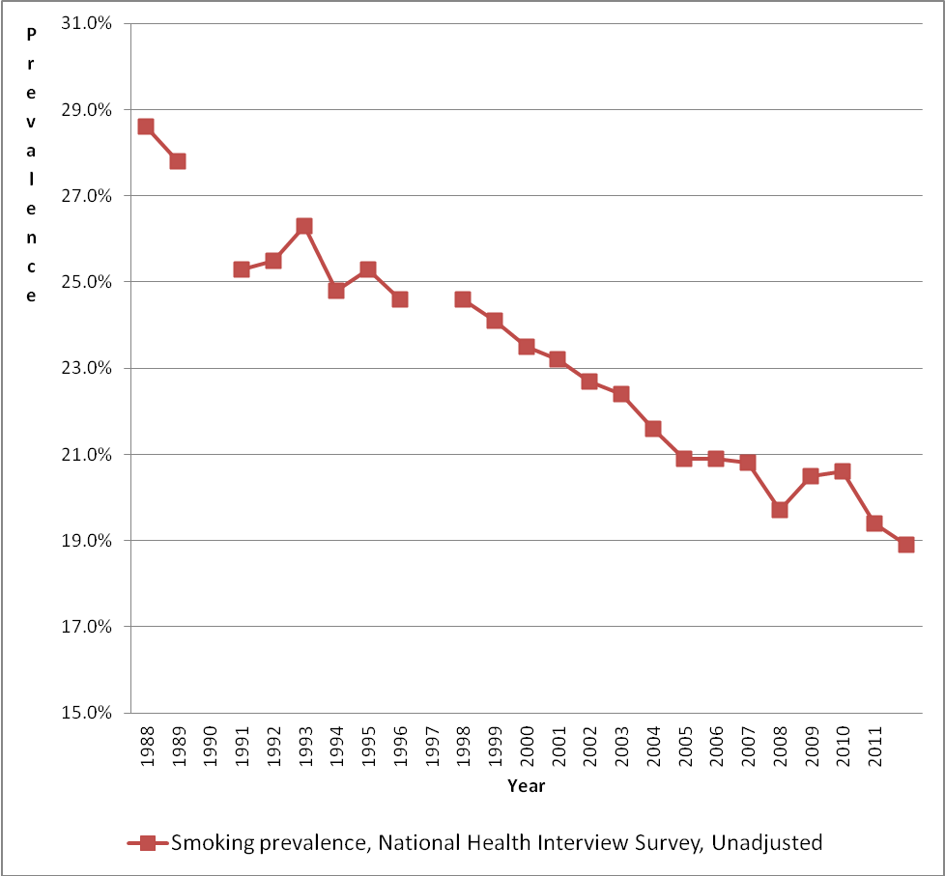

Figure 2. Smoking Prevlaence and Policies, 1988-2011
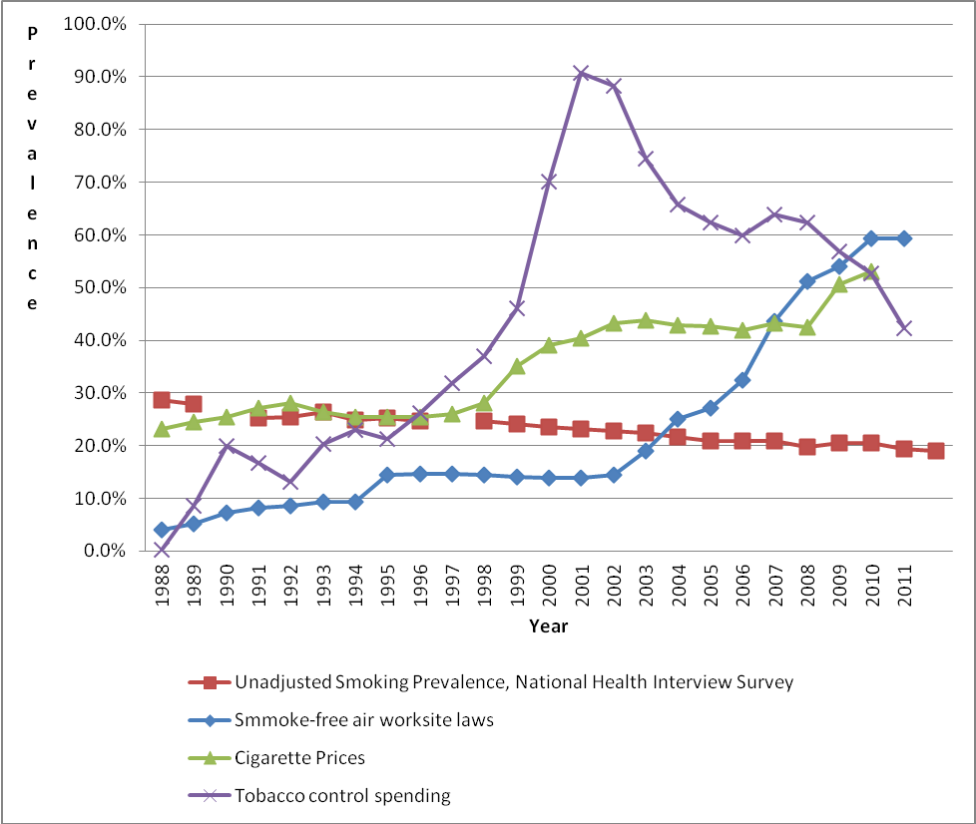
REFERENCES

1. Moolgavkar SH, Holford TR, Levy DT, Kong CY, Foy M, Clarke L, et al. Impact of reduced tobacco smoking on lung cancer mortality in the United States during 1975-2000. J Natl Cancer Inst 2012;104(7):541-8.
2. Anderson CM, Burns DM, Dodd KW, Feuer EJ. Chapter 2: Birth-cohort-specific estimates of smoking behaviors for the U.S. population. Risk Anal 2012;32 Suppl 1:S14-24.
3. Current cigarette smoking prevalence among working adults--United States, 2004-2010. MMWR Morb Mortal Wkly Rep 2011;60(38):1305-9.
4. Levy D, Mabry P, Graham A, Abrams D, CT O. Reaching Healthy People 2010 by 2013: A SimSmoke Simulation. Am J Prev Med 2010;38(38):S373-81.
5. Levy DT, Nikolayev L, Mumford E, Compton C. The Healthy People 2010 smoking prevalence and tobacco control objectives: results from the SimSmoke tobacco control policy simulation model (United States). Cancer Causes Control 2005;16(4):359-71.
6. Mendez D, Warner KE. Smoking prevalence in 2010: why the healthy people goal is unattainable. Am J Public Health 2000;90(3):401-3.
7. Mendez D, Warner KE. Setting a challenging yet realistic smoking prevalence target for Healthy People 2020: learning from the California experience. Am J Public Health 2008;98(3):556-9.
8. Levy DT, Nikolayev N, Mumford EA. The Healthy People 2010 Smoking Prevalence and Tobacco Control Objectives: Results from the SimSmoke Tobacco Control Policy Simulation Model. Cancer Causes and Control 2005;16(4):359-71.
9. Gilpin EA, Pierce JP, Farkas AJ. Duration of smoking abstinence and success in quitting. J Natl Cancer Inst 1997;89(8):572-6.
10. Hughes JR, Peters EN, Naud S. Relapse to smoking after 1 year of abstinence: a meta-analysis. Addict Behav 2008;33(12):1516-20.
11. U.S. DHHS. The Health Benefits of Smoking Cessation: a report of the Surgeon General. Atlanta Georgia: U.S. Department of Health and Human Services, Public Health Service, Centers for Disease Control, Office on Smoking and Health.; 1990.
12. Chaloupka F, Hu T, Warner K, Jacobs R, Yurekli A. The taxation of tobacco products. In: Jha P, Chaloupka F, editors. Tobacco control in developing countries.: Oxford University Press; 2000. p. 237-272.
13. Chaloupka F, Warner K. The economics of smoking. New York: North-Holland, Elseview Science B.V.; 1999.
14. Centers for Disease Control and Prevention (CDC). Cigarette smoking before and after an excise tax increase and an antismoking campaign--Massachusetts, 1990-1996. MMWR Morb Mortal Wkly Rep 1996;45(44):966-70.
15. Levy DT, Hyland A, Higbee C, Remer L, Compton C. The role of public policies in reducing smoking prevalence in California: results from the California tobacco policy simulation model. Health Policy 2007;82(2):167-85.
16. Levy DT, Ross H, Powell L, Bauer JE, Lee HR. The role of public policies in reducing smoking prevalence and deaths caused by smoking in Arizona: results from the Arizona tobacco policy simulation model. J Public Health Manag Pract 2007;13(1):59-67.
17. Friend K, Levy D. Smoking Cessation Interventions and Policies to Promote Their Use: A Critical Review. Nicotine and Tobacco Research 2001;3 (November):299-310.
18. Friend K, Levy DT. Reductions in smoking prevalence and cigarette consumption associated with mass-media campaigns. Health Educ Res 2002;17(1):85-98.
19. Levy DT, Friend K. A framework for evaluating and improving clean indoor air laws. J Public Health Manag Pract 2001;7(5):87-96.
20. Levy DT, Friend KB. A simulation model of tobacco youth access policies. J Health Polit Policy Law 2000;25(6):1023-50.
21. Levy DT, Friend KB. The effects of clean indoor air laws: what do we know and what do we need to know? Health Educ Res 2003;18(5):592-609.
22. Levy DT, Friend K. Gauging the effects of mass media policies: what do we need to know? J Public Health Manag Pract 2000;6(3):95-106.
23. Levy DT, Chaloupka F, Gitchell J. The effects of tobacco control policies on smoking rates: a tobacco control scorecard. J Public Health Manag Pract 2004;10(4):338-53.
24. Levy DT, Bauer J, Ross H, Powell L. The Role of Public Policies in Reducing Smoking Prevalence and Deaths Caused by Smoking in Arizona:Results from the Arizona Tobacco Policy Simulation Model. Journal of Public Health Management and Practice 2007.
25. Levy DT, Boyle RG, Abrams DB. The Role of Public Policies in Reducing Smoking: The Minnesota SimSmoke Tobacco Policy Model. Am J Prev Med 2012;43(5 Suppl 3):S179-86.
26. Levy DT, Hyland A, Higbee C, Remer L, Compton C. The role of public policies in reducing smoking prevalence in California: Results from the California Tobacco Policy Simulation Model. Health Policy 2007;82(2):153-166.
27. Levy DT, Tworek C, Hahn EJ, Davis RE. The Kentucky SimSmoke tobacco policy simulation model: reaching Healthy People 2010 goals through policy change. South Med J 2008;101(5):503-7.
28. Currie L, Levy D, Clancy L. The effect of tobacco control policies on smoking prevalence and smoking-attributable deaths using the Ireland SimSmoke Model. Tobacco Control 2012;epub.
29. Levy D, Currie L, Clancy L. Tobacco Control Policy in the United Kingdom: Blueprint for the Rest of Europe? European Journal of Public Health 2012;epub.
30. Levy D, de Almeida LM, Szklo A. The Brazil SimSmoke Policy Simulation Model: The Effect of Strong Tobacco Control Policies on Smoking Prevalence and Smoking-Attributable Deaths in a Middle Income Nation. PLoS Med 2012;9(11):e1001336.
31. Levy D, Gallus S, Blackman K, Carreras G, La Vecchia C, Gorini G. Italy SimSmoke: the effect of tobacco control policies on smoking prevalence and smoking attributable deaths in Italy. BMC Public Health 2012;12:709.
32. Levy D, Ross H, Kmentova A, Kralikova E, Stoklosa M, Blackman K. The Czech Republic SimSmoke: The Effect of Tobacco Control Policies on Smoking Prevalence and Smoking Attributable Deaths in the Czech Republic. ISRN Public Health 2012;2012, Article ID 329721, 8 pages, 2012. doi:10.5402/2012/329721.
33. Levy D, Zaloshjna E, Blackman K, Chaloupka F, Fong GT, editors. The Role of Tobacco Control Policies in Reducing Smoking and Deaths Caused by Smoking in the Eighteen Nations with the Largest Smoking Burden. Rockville, MD: National Cancer Institute Monograph; in press.
34. Levy DT, Benjakul S, Ross H, Ritthiphakdee B. The role of tobacco control policies in reducing smoking and deaths in a middle income nation: results from the Thailand SimSmoke simulation model. Tob Control 2008;17(1):53-9.
35. Levy DT, Blackman K, Currie LM, Levy J, Clancy L. SimSmokeFinn: How far can tobacco control policies move Finland toward tobacco-free 2040 goals? Scand J Public Health 2012;40(6):544-52.
36. Levy DT, Cho SI, Kim YM, Park S, Suh MK, Kam S. SimSmoke model evaluation of the effect of tobacco control policies in Korea: the unknown success story. Am J Public Health 2010;100(7):1267-73.
37. Levy DT, Nikolayev L, Mumford E. Recent trends in smoking and the role of public policies: results from the SimSmoke tobacco control policy simulation model. Addiction 2005;100(10):1526-36.
38. Nagelhout GE, Levy DT, Blackman K, Currie L, Clancy L, Willemsen MC. The effect of tobacco control policies on smoking prevalence and smoking-attributable deaths. Findings from the Netherlands SimSmoke Tobacco Control Policy Simulation Model. Addiction 2012;107(2):407-16.
39. Levy D, Graham A, Mabry P, Abrams D, CT O. Modeling the Impact of Smoking Cessation Treatment Policies on Quit Rates. Am J Prev Med 2010;38(38):S364-72.
40. Levy DT, Gitchell JG, Chaloupka F. The Effects of Tobacco Control Policies on Smoking Rates: A Tobacco Control Scorecard. J Public Health Manag Pract 2004;10:338-351.
41. Hu TW, Sung HY, Keeler TE. The state antismoking campaign and the industry response: the effects of advertising on cigarette consumption in California. Am Econ Rev 1995;85(2):85-90.
42. Sung H, Hu T, & Keeler TE. Cigarette taxation and demand: an empirical model. Contemporary Economic Policy 1994;12:91-100.
43. Levy DT, Cummings KM, Hyland A. Increasing taxes as a strategy to reduce cigarette use and deaths: results of a simulation model. Prev Med 2000;31(3):279-86.
44. Tauras J, Chaloupka F. Determinants of smoking cessation: An analysis of young adult men and women.: Edward Elgar Publishing Limited; 2001.
45. Levy D, Romano E, Mumford E. The Relationship of Smoking Cessation to Socio-Demographic Characteristics, Smoking Intensity and Tobacco Control Policies. Nicotine and Tobacco Research 2005;7 .(3):387-96.
46. Reed MB, Anderson CM, Vaughn JW, Burns DM. The effect of cigarette price increases on smoking cessation in California. Prev Sci 2008;9(1):47-54.
47. Jha P, Chaloupka FJ. The economics of global tobacco control. British Medical Journal 2000;321(7257):358-361.
48. Levy DT, Friend K, Polishchuk E. Effect of clean indoor air laws on smokers: the clean air module of the SimSmoke computer simulation model. Tob Control 2001;10(4):345-51.
49. Glasgow RE, Cummings KM, Hyland A. Relationship of worksite smoking policy to changes in employee tobacco use: findings from COMMIT. Tobacco Control 1997;6(suppl 2):S44-S48.
50. Burns DM, Anderson C, Major J, Vaughn J, Shanks T. Cessation and cessation measures among daily adult smokers: National- and State-specific data. In: Population Based Smoking Cessation Monograph No. 12. Washington, DC: National Institutes of Health. National Cancer Institute. NIH Publication No. 00-4804, 2000.39; 2000.
51. Farkas AJ, Gilpin EA, Distefan JM, Pierce JP. The effects of household and workplace smoking restrictions on quitting behaviours. Tob Control 1999;8(3):261-5.
52. American Nonsmokers' Rights Foundation. Summary of 100% Smokefree State Laws and Population Protected by 100% U.S. Smokefree Laws. In. Berkeley, CA: American Nonsmokers' Rights Foundation; 2009.
53. Centers for Disease Control and Prevention (CDC). Best Practices for Comprehensive Tobacco Control Programs—2007. . Atlanta, GA: U.S. Department of Health and Human Services; 2007 October 2007.
54. Institute of Medicine. Ending the tobacco problem: a blueprint for the nation. In; 2007; Washington, DC: The National Academies Press; 2007.
55. Hyland A, Li Q, Bauer JE, Giovino GA, Bauer U, Cummings KM. State and community tobacco-control programs and smoking-cessation rates among adult smokers: what can we learn from the COMMIT intervention cohort? Am J Health Promot 2006;20(4):272-81.
56. Levy DT, Friend K. Examining the effects of tobacco treatment policies on smoking rates and smoking related deaths using the SimSmoke computer simulation model. Tob Control 2002;11(1):47-54.
57. Levy DT, Friend K. A computer simulation model of mass media interventions directed at tobacco use. Prev.Med. 2001;32(3):284-294.
58. Campaign for Tobacco Free Kids. History of Spending for State Tobacco Prevention Programs FY2005 - FY2009. In. Washington, DC: Campaign for Tobacco Free Kids.; 2008.
59. Levy DT, Pearson JL, Villanti AC, Blackman K, Vallone DM, Niaura RS, et al. Modeling the future effects of a menthol ban on smoking prevalence and smoking-attributable deaths in the United States. Am J Public Health 2011;101(7):1236-40.

